AEA – AFTRA/SAG – AGMA – AGVA

Performer
Choreographer
Teacher
Writer

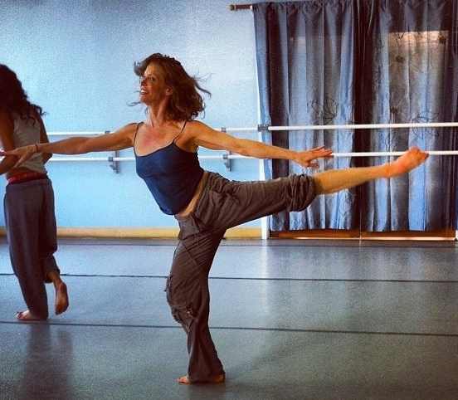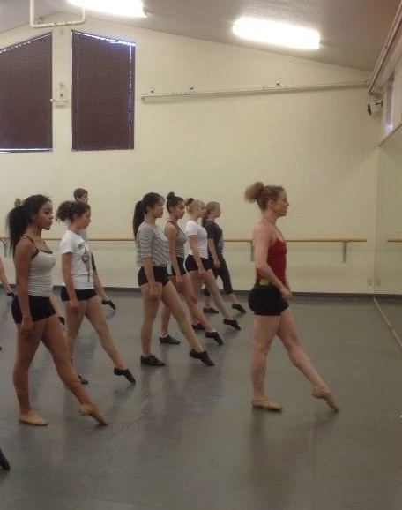

Leslie Stevens sirenrouge@yahoo.com www.lesliestevens.net www.imdb.com 818-209-1964
SAG/AFTRA - AEA – AGMA- AGVA
Choreographer
Dance and Movement Master Teacher
Librettist

CHOREOGRAPHY:
3-D Theatricals (www.3dtshows.org) - Multi Award-winning Equity company in Southern CA
HELLO DOLLY – Original Staging - Director, Ken Sawyer & TJ Dawson 2016
THE FULL MONTY – Original Staging - Director, TJ Dawson 2016
SIDE SHOW – Re-Work/Re-staging of Broadway Original version - Director, TJ Dawson 2015
INTO THE WOODS – Original staging – Director, TJ Dawson 2014

Independent Shakespeare Company – Uber Popular Los Angeles Summer Event 2015
ROMEO & JULIET – Created Disco Party - balcony scene movement
MUCH ADO ABOUT NOTHING – Created 40s Swing Finale

CSUN (California State University at Northridge) 2011 - 2014
2011 CABARET - Director, Ken Sawyer
2012 SPRING AWAKENING - Director, Garry Lennon (w/ Co-Choreographer, Yvette Tucker-Spencer)
2013 RAGTIME - Director, Ken Sawyer
2014 SWEENEY TODD - Director, Ken Sawyer

I include movement training to build skill and strength to execute choreography. Video Clips available upon request.

TEACHING:
AMDA-LA (American Musical and Dramatic Academy MFA program – www.amda.edu) 2011 – Present
Faculty - Part Time Adjunct Faculty. Ballet, Musical Theatre dance and Audition Technique. Intro to Ballet, Advanced Beginning, Intermediate and Pre-professional levels.

RELATIVITY SCHOOL (Commercial Dance MFA program - https://relativityschool.org) 2014 – Present Part Time Adjunct starting my 3rd semester - Ballet, Dance History-Iconic Choreographers, Musical Theatre

UCLA 2014 – Present
Recurring Guest Faculty - Senior/Juniors Musical Theatre Dance and Repertoire class.
I focus on alignment concepts, coordination of arms & legs and using clear body directions.
In charge of overseeing choreography, running rehearsals thru tech Into opening of “GUYS & DOLLS” 2014

LMU (Loyola Marymount Univ.), UCI (Univ. of California at Irvine), SMCC (Santa Monica Community College) - 2015 Recurring substitute faculty, Guest Teacher, Master Teacher – Musical theatre repertoire, original theatre movement/dance, ballet technique with a performance focus

Idyllwild Arts Academy (www.Idyllwildarts.org) 2009 - Present This prestigious Arts Conservatory/Boarding school for high school provides intensive training in Fine Arts. Guest Master Teacher: Contemporary Ballet/Modern (rep - Hubbard Street Dance Chicago), and Musical Theatre Dance Idyllwild Summer Program - Song and Dance - Original Musical Theatre Staging and Choreography and daily Movement/ Theatre Dance classes for various levels.
Los Angeles Opera / Opera Camp (www.laopera.org) 2005 – 2015 This is a summer intensive for young singers between 9 and 17. The program focuses on vocal technique, choral work, basic stage movements skills and physicality in story-telling. Director of Movement – Daily movement class w focus on alignment, stage awareness, intention and dynamics, strength training and basic vocabulary. There is close collaboration with the choir mistress and director to coordinate movement with vocal production. Assistant Director, staging & choreography for original operas, FRIEDL, BRUNDIBAR & THE WHITE BIRD OF POSTON.

LIBRETTIST:
Los Angeles Opera /Education and Community Engagement Dept. 2005 – 2016 Librettist for Education and Community Outreach Dept. – Author of libretti (play & lyrics) for 7 original pieces with this A-List opera company. These include revues of opera highlights, wrap around plays for existing operas, retranslations of classic repertoire and original historical dramas exploring cultural identity and social justice themes. The historical dramas were thoroughly vetted by nationally respected historical and cultural authorities. Scripts/scores/recordings available. These operas have been performed at the Dorothy Chandler Pavilion/ Grand Hall, the RedCat, Barnsdall Park Theatre, Pacific Asia Museum (Pasadena) and other Family Theatre & Cultural Education programs throughout Los Angeles
PERFORMER:
Professional Performing Career 30 Years and …
Musical Theatre/Dance/Acting on stage and on camera
I’ve had an extremely diverse career as a performer – based in different cities (Chicago, New York, Rome & Los Angeles), pursuing different forms and disciplines – Dance, Acting, Music, Choreography, Writing
I originated a principal role on Broadway in a Tony-Award winning show (Anne in LA CAGE AUX FOLLES)
I’ve been awarded Best Supporting Actress (short) & Best Actress (Feature) in noted National Film Festivals.
I spent 8 years as a concert dancer with Hubbard Street and Dayton Ballet - 15 years dancing with LA Opera
I was accepted into and completed the Shakespeare LAB classical acting training at The Public Theatre in NYC.
Please see performance resume for additional detail.

EDUCATION FROM THE PROFESSIONAL ARENA:

The Shakespeare LAB - The Public Theatre/ NYC 1997
Classical theatre intensive with elite professionals -Peter Francis James, Deborah Hecht, Barry Edelstein & others.

Soloist/ Company member - Hubbard Street Dance Chicago 1987 – 1992
Ballet, Modern and Contemporary dance training, rehearsal and performance with leading professionals including
Twyla Tharp, Margo Sappington, David Parsons, Lou Conte, Daniel Ezralow among others

Soloist/ Company member – Dayton Ballet 1992 – 1994
Classical and Contemporary dance training, (R.A.D. influenced) rehearsal and performance with Artistic Director James Clouser (interim Director – Houston Ballet)and Ballet Mistress Karen Williamson.

Performance Training 1980 – Present
Teachers and coaches have a huge impact on performing artists. I continue to learn from their input and insight. I list a few of the most influential ones here.
Ballet/Dance: Peff Modelski, Elena Kunikova, James Clouser(Current Chair of Ballet – U of AZ), Stefan Wenta
Vocal Music: Christina Saffron, Joann Zajac, Joel Pressman, Wendy Cooper
Acting: Diana Castle (current), William Metzo, The Public Theatre – Shakespeare LAB
Alexander Technique: Kristof Konrad

Professional Theatre Rehearsal and Performance (Hard Knocks University) 1983 – Present
I call my college “Hard Knocks U” in jest but most of my training and education was “On The Job”. I learned from the extraordinary artists I was allowed to work beside over weeks and years.
I list a few of the most influential ones (so far): Peff Modelski, Arthur Laurents, George Hearn, Jerry Adler, Margo Sappington, Lou Conte, Gwen Verdon, Bob Fosse, Graciella Danielle, Tony Stevens, Jon Jory, Adale O’Brien, Rob Marshall, Jason Robert Brown, Rob Fisher, Julie Andrews, David Lee, Wade Robeson, Sheldon Epps, Placido Domingo, Arthur Pita, Danny Pelzig, Gabriel Barre, Peggy Hickey, Darko Tresnak, Lee Martino, Erin Kamler, Rick Sparks, David O, Scott Thompson, Fred Barton, Ken Sawyer, TJ Dawson, MaryJo Duprey among others and new artists I meet every year.

Reels–www.lesliestevens.net; www.youtube.com (Leslie Stevens Actress), www.nowcasting.com/lesliestevens

REFERENCES:

IDYLLWILD ARTS: Jonathan Sharp - Ballet Chair @ Idyllwild Arts Academy - jsharp@idyllwildarts.org
David O – Director Song & Dance/Award-winning Musical Director - davidomusic@earthlink.net

LA OPERA: Eli Villanueva - Resident Stage Director Education Programs - eli.villanueva1@gmail.com Gretchen Meyerhoffer – LA Opera Casting Dancers/Chorus - gmeyerhoefer@laopera.org
RELATIVITY: Michelle Loucadoux –Director of Commercial Dance - mloucadoux@relativityschool.org
AMDA: Marina Benedict - AMDA Los Angeles Dance Department Co-Chair- mbenedict@amda.edu

PROFESSIONAL: TJ Dawson – Artistic Director 3D Theatricals - tdawson@3dtshows.com Rick Sparks – Multi-Award winning Stage director - sparksmambo@aol.com
Peggy Hickey - choreographer -LA Opera, Bway; faculty UCLA – peghickey1@aol.com

